

Business Intelligence

Matthew Crosby | 10170652

Matthew Crosby | 10170652

Contents

Task 1 2

What is the difference between the business process and the supporting process? 2

Business Process 2

Supporting Process 2

What is the difference between unstructured and semi-structured data within a business/organization? 3

Task 2 4

Types of support available for business decision-making within an organisation 4

Key features of business intelligence functionality 6

Task 3 7

What is Buisness Intelligence and what are the tools/techniques associated with it? 7

Task 4 11

how buisness intelligence tools contribute to effective decision making. 11

Are there any examples of BUSINESS that use BUSINESS Intelligence? 12

Legal Issues involved in the explotation of business intelligence tools. 13

References/Bibliography 14

# Task 1

## What is the difference between the business process and the supporting process?

### Business Process

The business process is multiple steps that a company will carry out in order to achieve a goal, such as creating a product. Within this process a business can be either manual or automated. If the business is manual then jobs wouldn’t be done by robots in factories, this can lead to more human error in certain fields. If the process is automated then jobs will be done using programs, algorithms and robots that can perform a job without human interaction. In a business/company such as Mercedes many processes that require perfect precision such as cutting all the panels the right shape and size will be done by automation but in higher end cars more is done manual to give the car the human touch allowing for the client to customize their car whilst it’s being built. Also, within the business process jobs such as payroll to all employees will be included as this is needed for the company to run without failing. Another part is customer service where the client can customize their future car as some high-end cars rely on customization to make a car unique as the more expensive the less that are made.

### Supporting Process

The supporting process is the steps to sell the car in this example, so process such as obtaining a license to be able to sell cars in this quantity and quality, and advertising to be able to get more eyes looking at the car. When a company such as Mercedes advertises, they will advertise on billboards for drivers to see as drivers are the target buyers but also, they will advertise on TV and on the radio about their car. Many car companies use TV advertisements as a way to give a message of some kind as these advertisements don’t really say what the car has but more give visual hints to what the car has. Another process that will help in selling cars is testing to make sure the car works correctly, it doesn’t need to be done but doing so will prove the car works thus improving the chance that the car will sell.

An example of a business is amazon whom have multiple departments that can be split between both of these processes. The main core departments of the business are areas which help to maintain the business and represent essential business activities to accomplish an objective that the business has. Examples of these are areas that take customer orders and manage the bank accounts of customers, these help to generate revenue. Supporting processes such as accounting and human resources support the core business processes. The difference between these is that the supporting process does not direcly provide value to customers buying a product.

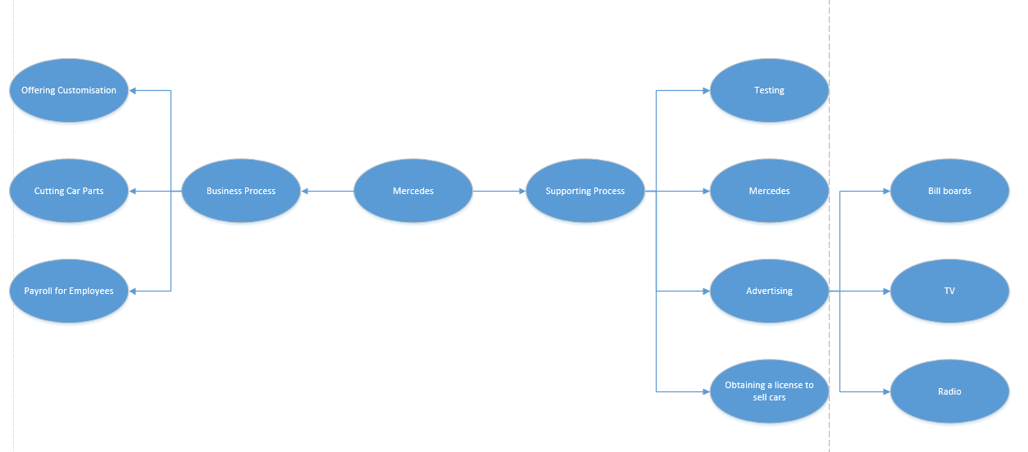

## What is the difference between unstructured and semi-structured data within a business/organization?

Within a business data is collected from the customers/clients, this data is used to see satisfaction of customers but also how they are improving the business which can allow for that business to create a business plan. This data however can be confusing and not always easy to read so a business can use a CRM to create visuals of the data and easily see what is doing well and what could be improved

|  |  |  |
| --- | --- | --- |
| Unstructured Data | Semi-Structured Data | Structured Data |
| Unstructured data come in many different formats that relate to video files, audio files and images, but gaining information from unstructured data. To be able to process this type of data a lot of processing power is required to gain intelligence. Other types of unstructured data include: webpages, emails, chats and pdf files. A lot of webpages use unstructured data such as YouTube to see how many people view a video for example, this is raw data that has not been analysed to gain intelligence for the company. | Semi-Structured data is still data that cannot easily be searched but it is easier, the similarity however is that it still cannot be analysed. An example of a real life scenario with semi structured data is a database, this is because a database has associated information such as metadata that makes it easier to process. Semi structured data is also flexible, not as flexible as unstructured data but still somewhat flexible. | Structured data is data where the elements are addressable for effective analysis. This type of data has been formatted and resides in a database most commonly. All the data within this database is stores in tables and columns in SQL. Structured Data has relational keys and can easily be used to find relations between data as well as mapping into pre-designed fields. An example is relational data. |
| The difference when compared to Semi-Structured is semi-structured data is data which has some structure to it and can somewhat be used to aid the business.  Unstructured data has no pre-defined data model and can be text, images, audio, and video which can make it hard to search. This type of data is usually found in applications and social media.  Unstructured data would most commonly be applied to presentations, emails and any media editing applications such as Adobe Premier.  Semi structured data has information associated to it such as meta data making is more likely to analyse and allow for elements contained to be addressed.  The technology of structured data is based on a relational database table making it easier to analyse whilst semi structured data is based on XML and RDF. Unstructured data when being compared to these other two types of data is based on character and binary data.  Structured data is also very scheme dependant making it less flexible whilst unstructured data is the most flexible as there is no dependency on schemas. In-between these two is semi-structured data which is more flexible than structured data but less than unstructured data.  The complexity of joining also differ between these different types of data, structure has complex joining due to structed queries whilst semi structured data allows for queries over anonymous nodes and unstructured only allows for textual queries. | | |

# Task 2

## Types of support available for business decision-making within an organisation

A continuous analysis of decision making within an organisation allows for high quality and transparent decisions. Without this a business would run with prejudice which is the notion that it is good at making decisions, even if it is not good at making decisions. In a business nothing will happen until someone makes a decision and the speed now that the market moves, businesses will need to quickly make decisions to keep on top of it all, for example a decision that was made today may be the wrong decision tomorrow.

One method is decide and announce, this is to review options such as objectives, timescale, priorities and then decide on what action to take, after this the team is informed of what decision has been made. The disadvantage of this however is that this method will more than likely demotivate teams that are experienced as it makes them feel “unappreciated and productivity declined.” (inc.com 04/04/2019)

Another method is to decide and then communicate the decision to others such as the team, company and customers, what would be discussed are the reasons for making that decision and then the positive benefits that decision will have. With this approach the decision is part of the learning process so will increase the motivation and confidence of the team.

Presenting the decision that has been made and then asking for comments is another method. This method is where the decision is presented with all the background showing how the decision was made and then allowing for the team to ask questions and discuss the decision. This allows for more participation in what is happening within the business and allows for a more engaging approach improving satisfaction.

A method like the last is presenting the situation and allowing for input and a discussion, this allows for a team to come up with multiple decisions and then allows them to discuss which decision they should take. This allows for a team to be highly involved with the overall decision.

Another method is to ask the team what problems the business has and allow then to make the decision. This approach allows for team members to identify and analyse the current situation to be able to decide on what action should be taken. This puts the team in a decision-making level that is very strategic.

By comparing these I can see that they all have their advantages and disadvantages, for example with the first method, this being deciding the decision and then announcing it, allows for a business to quickly make a decision if there is a short timeframe, but the disadvantage of this is that the team will not be involved a lot so will make them feel less productive. In the second method, allowing for a discussion to be made on the decision, this allows for the team to be more involved with the decision. The team still won’t be involved with decision as much as in the third and fourth method, these two methods are very similar other than one allows for comments to be made about the decision decided and the second allows for the team to discuss multiple decisions. These have advantages such as allowing for the team to be more involved and productive as well as putting the team in a strategic decision-making level. A disadvantage of these however is that it does not give the team control on what decision should be made allowing for a biased opinion. Finally, the last method I mentioned allows for the team to make the decision. The advantage of this is that it allows for the team to discuss what should happen within the business, but a disadvantage of this is that it is very time consuming and the speed of which decisions need to be made within a business needs to be very fast to be able to keep up with the current market.

## Key features of business intelligence functionality

A business will have many reasons for why they may want to invest in a Business Intelligence solution based on what industry the business is in and the circumstances the business faces. From yellowfinbi.com Lach James compares this by watching movies, he states “It’s like watching scary movies. Some of us put ourselves through the ordeal because we enjoy the thrill. Others will just participate because it’s what everyone else is doing. And some go along looking for an excuse to squeeze that special someone extra tight during those conveniently frequent moments of terror.” This shows that there can be multiple reasons for investing in a BI solution that result in the same outcome. Below will be some key features with business intelligence software.

Personalised dashboards are one feature, this allows for an easy to understand visual on real time data that is currently occurring within the business, this allows for faster and better decision making as all the information and trends required to be able to decide on a decision is all visualised for a team to see. This also lowers response times to any internal and external events. A CEO or Executive within a business will need to have access to this kind of information as it allows to easily understand the information and be able to summarise it regularly. This eliminates the hassle of dealing with irrelevant information. An example of software where personalised dashboards is used are in Microsoft BI, Microsoft BI allows for a business to bundle up reports and datasets into one dashboard that can be customised to the user’s preference.

Location Intelligence is another key feature, it allows for a visual map to be displayed that shows data in a geographical format, this allows for a business to understand their business operations by showing them data such as sales per region. This is an advantage to a business as it can mean the decision that is decided can be more relevant to the mass amount of people, for example that could be in more economical countries such as U.S.A or the United Kingdom. An example of BI software that uses location intelligence is Yellow Fin, in the image below you can see an example of a Location Intelligence map, this is showing the Crime Data in Chicago and where the lowest and highest number of incidences have occurred. This can be good for a Police Department as it allows for them to be able to devote for resources such as officers to an area that has a higher incident rating rather than wasting resources on an area where nothing will happen. Just from looking at this image a police department can make a fast decision on where to locate their officers.

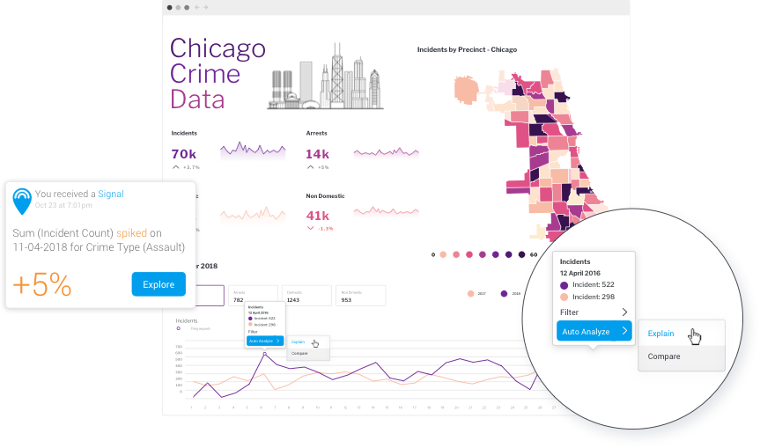<https://www.yellowfinbi.com/assets/files/2018/11/Yellowfin_Dashboard_Signal_Analyze_.png>

What If analysis is another key feature that allows for a business to asses any potential effects of a decision before it is implemented. It does this by using data that already exists to be able to create a formula to help a business avoid the “hit and miss approach” (yellowfinbi.com 04/04/2019) allowing for accurate strategic planning. In other words, it allows for a business to predict potential impacts to give a better understanding of the risks and rewards allowing for faster and better decisions. An example where what if is used is in Sisense BI, the roles it plays for a business are the same as mentioned above.

Another key feature is interactive reports which allows for a business to convert the data they have gathered into knowledge helping the business to better understand reports, and he data that the reports are based on helping in decision making. A few tasks that a team should be able to be are: being able to thoroughly analyse reports, conduct slice and dice OLAP analysis, be able to apply analysis such as regression to be able to highlight trends in data. Another task a user should be able to do is to be able to look at large data sets to be able to spot any anomalies. Finally, the user should also be able to highlight data exceptions from conditional formatting to data alerts. An example of a BI software that uses this is Yellowfin which allows you to “Tell powerful stories with your data” (Yellowfinbi.com 04/04/2019) thus allowing for you to engage with the audience to help better decide on a decision that should be implemented.

# Task 3

## What is Buisness Intelligence and what are the tools/techniques associated with it?

Business Intelligence is a set of tools and techniques that support the process of transforming raw data into useful data which can be used in decision making. Business Intelligence gives reporting functionality, tools which can be used to identify data structures, support for the techniques used in data mining, allow for performance management and predictive analysis.

The main aim of Business Intelligence is to support decision making, therefore BI tools are also called Decision Support Systems or fact-based support systems as they allow for the user to analyse the data they have and then extract information from that data. Business Intelligence combines both internal and external data from a variety of sources that the company or business has collected. An example is data that has been collected by a company from its production process, this can be used to gain insights which will lead to the company understanding how to improve the pr0duction process.

Are there any examples of Business Intelligence being used in practice? Yes, one example is an online transaction processing system. Within this system information can be added to the product database to either add a new product or change the price of a product. In an advertising database that uses an online transaction processing system this same method can be used to change the advertisement options and increase the budget, as well as this within a BI system a query can be executed to see how many new clients there are due to the change of budget.

Another example of a BI system being used in practice is a hotel owner that can use analytic applications to gather statistical information about the average amount of occupants and the room rate, as well as this is can also help to find out the revenue of each room. This information can be used to decide the competitive position in the hotel market. If the owner was to analyse these trends each day, month or year it can help management to decide on discounts and offers.

A third example is a bank which gives managers of each branch access to BI applications, this helps the manager to see who the most profitable customers within the bank are and who needs some work. By using BI tools, the bank managers can free IT staff from generating analytic reports allowing for a more efficient use of resources.

There are four types of BI users who play a key part within the business intelligence system. The first of these being the professional data analyst whose job is to carefully analyse data as efficiently and as accurate as possible. By using BI systems, the data analyst can get up to date insights which can be used to generate unique business strategies.

The second of these users is the IT user who plays an important role by maintaining the infrastructure of the BI as without a business can lose out on strategies, money and time.

The third of these users is the CEO of the company, they can increase profit within their business by improving the overall efficiency within the business, by using a BI system this can increase the efficiency by a lot.

Finally, the fourth user is the business user, a business user can be places anywhere within the business hierarchy and is split into two categories, the first being the casual business intelligence user who will use visual dashboards to evaluate predefined datasets. The second being the power user who has the capability to work with complex data sets.

What are the advantages within business intelligence? Firstly, BI applications can increase productivity, when using a BI program, it is possible for a business to create reports within seconds saving time and resources, this allows for employees to be more productive on other tasks. Another advantage is that it improves the visibility of these processes and can help a business to spot what areas need attention. BI systems can also fix accountability, it does this by assigning accountability in the organisation. Another advantage is that it streamlines business processes by taking the complexity away from the business processes, an example of this is by automating analytics that are offered by predictive analysis, benchmarking computer modelling and other methodologies.

Where there are advantages though there are also disadvantages, one of these being cost, the cost of a BI system can be very expensive for smaller businesses as well as medium sided businesses, when a business comes to do routine business transactions it can be very expensive. Another disadvantage is the complexity that a BI system has in implementing a Datawarehouse, this can be so complex that a business may finds it too rigid to deal with. Another disadvantage is he time it takes to implement this Datawarehouse, sometimes this can take one and a half years to do.

What are some techniques that are used in Business Intelligence? One of many techniques used is Data Visualisation. When data is stored as a big set of numbers it can be hard to understand although it may be accurate. An example is, is a business’s sale going up, down or staying the same. When looking at more than one set of data things can get difficult, that’s where visualisation of data comes into play, it helps a user to understand an interpret data.

Another technique is Data Mining. Data mining is a supported method used to reveal unnoticed relations between data, an example of where this is used is in a shopping basket, data mining can analyse this data to promote similar products to the user, this technique is used to try and sell more to the buyer. In a bank a client risk assessment is used so that an evaluation can be made whether a client is going to pay back a loan or not based on their previous data. And finally, in the fraud detection within businesses, this is calculated via previous behavioural data so see whether a user is most likely to attempt fraud.

Another tool/technique is reporting. The design and generation of the performance, sales and savings reports is an area where a BI can help a user. Reports generated by a BI tool are more accurate, efficient and neatly present all information ready to present to the management team which can then lead onto the decision-making process. A good feature of this tool is that once the report is designed it can automatically be sent off to predefined users.

Another tool is time series analysis, almost all data warehouses have a time dataset, examples of where this is used is in product sales, phone calls and patient hospitalizations. All of these need the changes to be set based on user behaviour in time, relation between the products or changes in sale contracts due to marketing promotions. This time series analysis can also be used to spot trends by analysing previous data.

Online Analytic Processing or OLAP is another technique used in Business Intelligence. OLAP is known for OLAP-cubes which give a visualisation of multidimensional data, this data is displayed on cube edges with the dimensions being measured in time, product, customer age, or customer type. The values for this OLAP cube could be the value of the contracts or the number of products sold. The way that users navigate an OLAP cube is by using features such as drill-up, drill-down and drill-across. These features allow for a user to easily zoom in or out to find more details and navigating to another OLAP cube to see if there are any relations between them. All the functionality is provided in real time to the user. 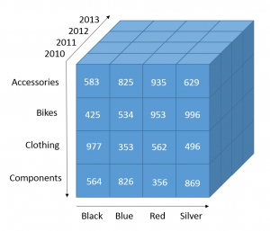

Finally, statistical analysis in another tool used in business intelligence. This tool uses mathematical foundations to be able to judge the significance and reliability of the relations. According to an article the most interesting features are “distribution analysis, confidence intervals (for example for changes in user behaviours, etc). Statistical analysis is used for devising and analysing the results from data mining.” (Data Integration Info)

Some examples of popular business intelligence tools include:

* SAP Business Objects Enterprise
* SAP NetWeaver BI
* SAS Enterprise BI Server
* Actuate
* Microsoft BI platform
* BizzScore Suite
* WebFocus
* Microstrategy
* Board Management IntelligenceToolkit
* Oracle Hyperion System
* Oracle Enterprise BI Server

# Task 4

## how buisness intelligence tools contribute to effective decision making.

Like I previously stated the main purpose of business intelligence is to help in decision making, and with the proper BI system a business owner/CEO can access the right information in real time in the correct format. This also helps in the business achieving its business goals and targets by making the correct decisions.

Interactions with clients through emails, online chats and phone calls can be analysed and then used to get insights that can promote the values of the business. This also can be used to increase customer satisfaction in the future.

So how do business intelligence tools contribute to effective decision making. Well in the marketing department for example it can help them analyse the results of their promotions and campaigns. In the sales department of a business BI can help in finding the best path and best practices, the length of customer acquisition, process improvement and a yearly analysis of the turnover and sales. In the human resources department business intelligence can help them to manage recruitment, attrition rate and employee turnover. This is only a few examples of where business intelligence can impact a department, there are many others within a business and BI impacts all of them in some way.

Business intelligence has many different types of powerful techniques/tools to aid in decision making, some of these are Interactivity, data visualisation, database connection, predictive analysis and application integration.

So how do these tools/techniques help in decision making, well in interactivity there needs to be a high amount of interaction with the data. If someone within the business in analysing the sales report of the business interaction needs to be involved. This will lead to a better analysis by digging into the report more which will lead to figuring out the regional sales, products sold in a period and which product have sold most. This better analysed data can then be used to decide what direction the business needs to go in next.

Another tool is data visualisation which when displayed in the correct format will lead to a better understanding of the data. An example is how much a certain product has made over the year, instead of words a bar chart can be used to show how much money has been made over the year, this makes it very easy to spot trends and see how much the product sales have increased/decreased over the months. Only when data is presented in the correct format can it be used for insight. This can help in a business making decisions based on what they have presented in front of them, for example if the data was about inventory management, the company could decide when to order next.

Another tool/technique is connection to databases. During the BI procedure the analysis should be able to fetch the information then need by connecting to several databases and web services as having this information at hand helps to gain recommendations which will help in growing the business.

Finally, application integration is another technique used in business intelligence. A business intelligence tool should very easy to integrate with existing applications using many languages such as C#, C++, Java and Python. This makes it very widely available and easy to access no matter what field a business is in.

By using marketing strategy, a company can quickly make decisions to best suit their products, BI tools can be used to analyse campaign outcomes and then use that to prioritise campaigns. This allows for a business to fine tune their process and marketing strategy.

Another technique that a company can use is by using BI tools to manage inventory stock, by analysing this data a company can reduce the amount of excess inventory which will save the business cost. This also gives the company better visibility and can show them when and what to order.

## Are there any examples of BUSINESS that use BUSINESS Intelligence?

There are many examples of businesses that use different tools to solve their problems that they may be facing. Once of these businesses is HelloFresh. Hello Fresh had a problem of digital marketing reporting which was very time intensive, and very inefficient. The company instead decided to use automatic reporting processes which saved the analytics team 10-20 hours per day of work.

Another example is REI which had difficulty tracking membership metrics as they had 90 terabytes of data to handle. The way the REI solved this problem by using Business Intelligence applications to analyse their data. By parsing all this information, the operations team can decide whether to invest more into digital expenses.

Coca Cola was also a company that used business intelligence to solve their problems. Their issue was that manual reporting prevented access to view real time sales and operations data. The way the company tackled this issue was by using BI tools to handle all the reporting including all sales and deliveries. With the BI application the team at Coca cola save over 260 a year.

Another organisation t use Business Intelligence to solve their problem was Des Moines Public Schools. Their problem was that reporting in excel manually meant admins couldn’t see real time data such as attendance. Their solution was to use advanced analytics to improve the dropout rates as well as getting a better understanding of the impacts of different reaching methods on student outcomes. The schools used a multiple linear regression model which predicted which students may be at risk of dropping out of school.

## Legal Issues involved in the explotation of business intelligence tools.

With data there is a general rule that applies to it, that is if data is left unattended for long enough it will cause damage. With a business using BI information is going to be passing in and out of the system all the time, and when this is analysed it allows for sensitive data to be hacked. If this data is stolen, they could do anything related to the data, for example if they hack the data which includes the whole process, they could hijack the whole system. There could also be the chance that there is an internal thread such as someone leaking data which can lead to numerous issues. There more data that is being analysed the bigger the breaches will be, and this information will more than likely contain some personal or sensitive information.

If a business was to build a big data infrastructure in house, then they would not have the risk of cloud security being breached, but if a company does choose to do this then the security of it should be considered. There are a few challenges with huge amount of data and the privacy of that data, these issues fall into four categories, these being, infrastructure security, data privacy, data management and integrity security.

One risk is that the anonymisation of data/data masking could prove to be impossible. Within some businesses data goes through a process of anonymisation so that the data can be used for marketing without the risk of information leaking, but no database is completely anonymous. Reidentification is completely possible and can lead to harmful results if done correctly, this can reveal information such as medical history, personal habits, family relations and financial status.

Security breaches damage a company and create legal issues. Firstly, a security breach causes the loss of company secrets such as how they work the business. This could be used against them to knock them out the competition. Also, the loss of confidential information may damage the future of the business. Breaches within the business can impact the company’s reputation, if a business that handles data such as one using a BI system and it gets breached then people won’t feel as safe giving up their information to the company. This could cause loss as customers could go to other competing businesses. Another issue is the cost of having to fix these breaches as some companies may need to hire forensic experts to see where the source of the breach came from. It could either come from an internal breach from an employee or it could have been caused by a cyber-attack.

# References/Bibliography

Appian. (2019). Business Process Definition - What is Business Process? | Appian. [online] Available at: https://www.appian.com/bpm/definition-of-a-business-process/ [Accessed 3 Feb. 2019].

Blog.signaturit.com. (2019). What is Business Intelligence (BI) and what tools exist?. [online] Available at: https://blog.signaturit.com/en/what-is-business-intelligence-bi-and-what-tools-exist [Accessed 9 Jun. 2019].

CCS Technology Group. (2019). Real-world examples of business intelligence at work. [online] Available at: https://www.ccstechnologygroup.com/real-world-examples-of-business-intelligence/ [Accessed 11 Jun. 2019].

Dataintegration.info. (2019). Business Intelligence | Data Integration Info. [online] Available at: https://www.dataintegration.info/business-intelligence [Accessed 9 Jun. 2019].

Datamation.com. (2019). Structured vs. Unstructured Data. [online] Available at: https://www.datamation.com/big-data/structured-vs-unstructured-data.html [Accessed 3 Feb. 2019].

Ft.com. (2019). Confronting the privacy and ethical risks of Big Data | Financial Times. [online] Available at: https://www.ft.com/content/105e30a4-2549-11e3-b349-00144feab7de [Accessed 11 Jun. 2019].

GeeksforGeeks. (2019). Difference between Structured, Semi-structured and Unstructured data - GeeksforGeeks. [online] Available at: https://www.geeksforgeeks.org/difference-between-structured-semi-structured-and-unstructured-data/ [Accessed 3 Feb. 2019].

Guru99.com. (2019). [online] Available at: https://www.guru99.com/business-intelligence-definition-example.html [Accessed 9 Jun. 2019].

Inc.com. (2019). There Are 7 Types of Decision-Making. Which One Is Best For You?. [online] Available at: https://www.inc.com/martin-zwilling/there-are-7-types-of-decision-making-which-one-is-best-for-you.html [Accessed 4 Apr. 2019].

Linkedin.com. (2019). Business Intelligence - Concept, Tools and Techniques. [online] Available at: https://www.linkedin.com/pulse/business-intelligence-concept-tools-techniques-ishwar-saswade [Accessed 9 Jun. 2019].

PNMsoft. (2019). Business Processes - Explanation and Examples. [online] Available at: http://www.pnmsoft.com/resources/bpm-tutorial/business-process/ [Accessed 3 Feb. 2019].

Profitableventure.com. (2019). How Business Intelligence Helps in Decision Making | ProfitableVenture. [online] Available at: https://www.profitableventure.com/intelligence-decision-making/ [Accessed 11 Jun. 2019].

References

Schaefer, P. (2019). Differences Between Structured & Unstructured Data. [online] Trifacta. Available at: https://www.trifacta.com/blog/structured-unstructured-data/ [Accessed 3 Feb. 2019].

SearchCIO. (2019). What is business process? - Definition from WhatIs.com. [online] Available at: https://searchcio.techtarget.com/definition/business-process [Accessed 3 Feb. 2019].

Selecthub.com. (2019). Types of Business Intelligence Tools & Systems | What's Hot in 2019?. [online] Available at: https://selecthub.com/business-intelligence/key-types-business-intelligence-tools/ [Accessed 9 Jun. 2019].

Software, P. (2019). 5 ways companies are making better decisions with industry specific data analytics. [online] Phocassoftware.com. Available at: https://www.phocassoftware.com/business-intelligence-blog/5-ways-companies-are-making-better-decisions-with-business-intelligence [Accessed 11 Jun. 2019].

Sowells, J. (2019). Understanding Business Intelligence and Data Security. [online] Hackercombat.com. Available at: https://hackercombat.com/understanding-business-intelligence-and-data-security/ [Accessed 11 Jun. 2019].

Svlg.com. (2019). Data Security Breaches: A Legal Guide to Prevention and Incident Response. [online] Available at: https://www.svlg.com/data-security-breaches-a-legal-guide-to-prevention-and-incident.html [Accessed 11 Jun. 2019].

Tableau Software. (2019). 5 real examples of business intelligence in action. [online] Available at: https://www.tableau.com/learn/articles/business-intelligence-examples [Accessed 11 Jun. 2019].

Techfunnel. (2019). Top Business Intelligence Tools and Techniques. [online] Available at: https://www.techfunnel.com/information-technology/top-business-intelligence-tools-and-techniques/ [Accessed 9 Jun. 2019].

WhatIs.com. (2019). What is semi-structured data? - Definition from WhatIs.com. [online] Available at: https://whatis.techtarget.com/definition/semi-structured-data [Accessed 3 Feb. 2019].